**[BASIC C PROGRAMMING](http://118.185.187.137/moodle/course/view.php?id=158" \l "section-1)**

**AIM:**

Write a C program to swap two given numbers.

**PROGRAM:**

#include<stdio.h>

int main()

{

int a,b;

scanf("%d %d",&a,&b);

int temp;

temp=a;

a=b;

b=temp;

printf("%d %d",a,b);

}

**OUTPUT:**

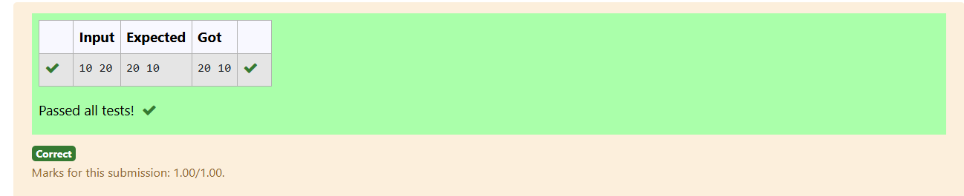

**AIM:**

Write a C program to determine admission eligibility based on specified subject mark criteria.

**PROGRAM:**

#include<stdio.h>

int main()

{

int a,b,c;

scanf("%d %d %d",&a,&b,&c);

if((a+b+c)>=180)

{

printf("The candidate is eligible");

}

else

{

printf("The candidate is not eligible");

}

}

**OUTPUT:**

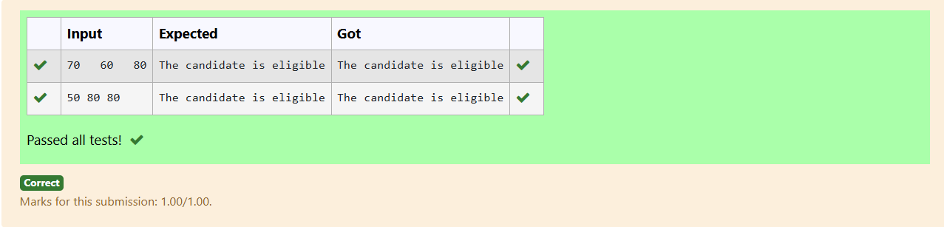

**AIM:**

Write a C program to calculate the final bill after applying a discount for a specified minimum amount.

**PROGRAM:**

#include<stdio.h>

int main()

{

int bill;

scanf("%d",&bill);

if(bill>2000)

{

int d=10*bill;

int d1=d/100;

printf("%d",bill-d1);

}

else

{

printf("%d",bill);

}

}

**OUTPUT:**

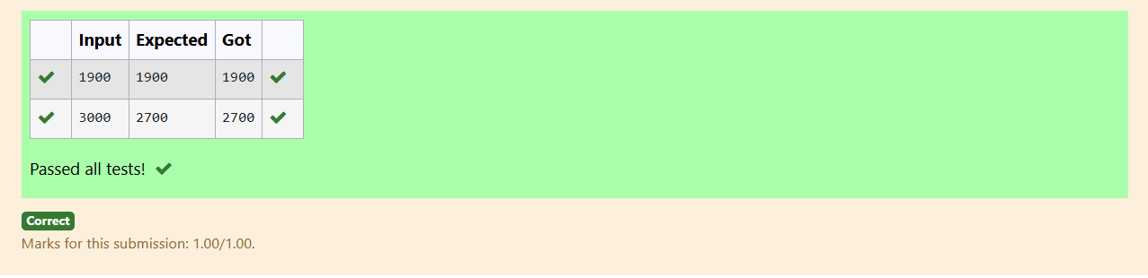

**AIM:**

Write a C program to find the initial amount Baba had based on donations given to beggars.

**PROGRAM:**

#include<stdio.h>

int main()

{

int m,b;

scanf("%d %d",&m,&b);

int im=m;

for(int i=1;i<=b;i++)

{

im=im*2;

}

printf("%d",im);

}

**OUTPUT:**

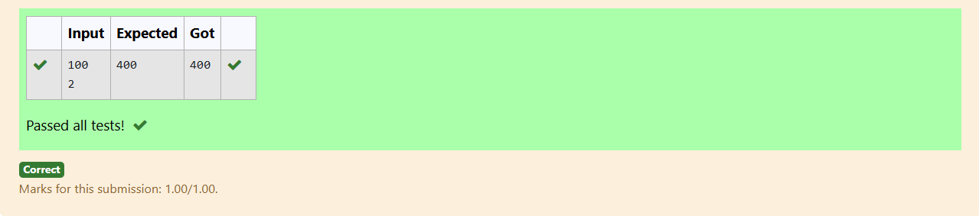

**AIM:**

Write a C program to calculate the "Punctuality Incentive" based on consecutive on-time days.

**PROGRAM:**

#include<stdio.h>

int main()

{

int m,n;

scanf("%d",&m);

scanf("%d",&n);

int sal=m;

int ts=sal;

for(int i=1;i<n;i++)

{

sal=sal+200;

ts=ts+sal;

}

printf("%d",ts);

}

**OUTPUT:**

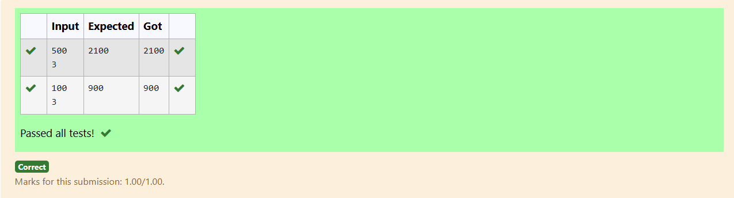

**AIM:**

Write a C program to print numbers divisible by a specified number within a given range.

**PROGRAM:**

#include<stdio.h>

int main()

{

int m,n,x;

scanf("%d",&m);

scanf("%d",&n);

scanf("%d",&x);

for(int i=n;i>=m;i--)

{

if(i%x==0)

{

printf("%d ",i);

}

}

}

**OUTPUT:**

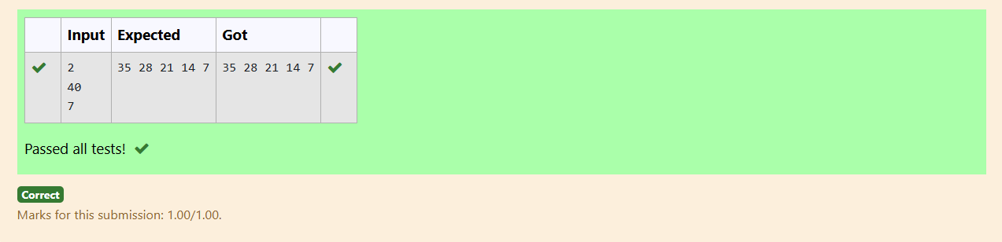

**AIM:**

Write a C program to calculate the quotient and remainder of two integers.

**PROGRAM:**

#include<stdio.h>

int main()

{

int x,y;

scanf("%d",&x);

scanf("%d",&y);

int q=x/y;

int r=x%y;

printf("%d\n",q);

printf("%d",r);

}

**OUTPUT:**

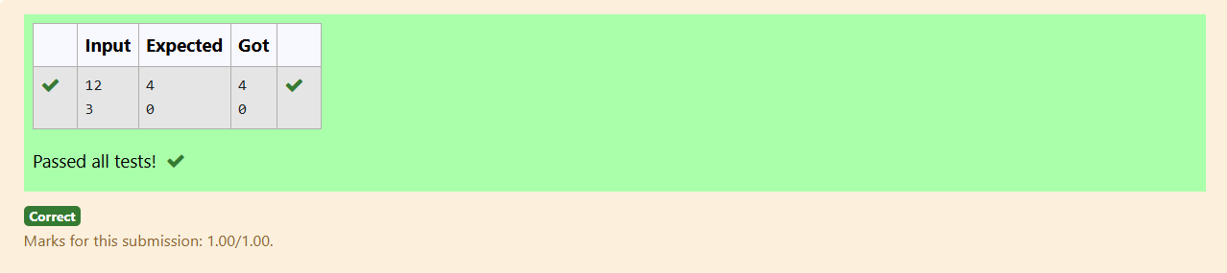

**AIM:**

Write a C program to find the largest of three given integers.

**PROGRAM:**

#include<stdio.h>

int main()

{

int a,b,c;

scanf("%d %d %d",&a,&b,&c);

if(a>b && a>c)

{

printf("%d",a);

}

else if(b>a && b>c)

{

printf("%d",b);

}

else

{

printf("%d",c);

}

}

**OUTPUT:**

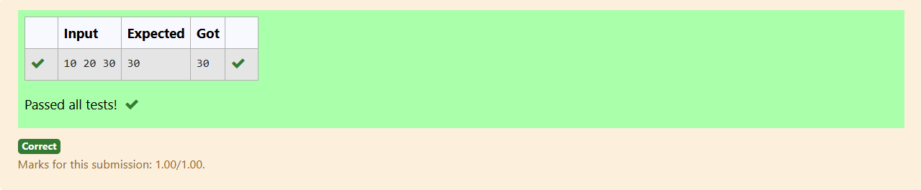

**AIM:**

Write a C program to determine if a given integer is odd or even.

**PROGRAM:**

#include<stdio.h>

int main()

{

int n;

scanf("%d",&n);

if(n%2==0)

printf("Even");

else

printf("Odd");

}

**OUTPUT:**

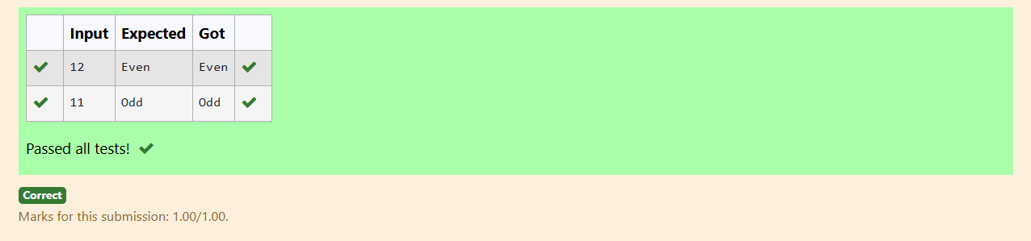

**AIM:**

Write a C program to calculate the factorial of a given number.

**PROGRAM:**

#include<stdio.h>

int main()

{

int n;

scanf("%d",&n);

int fac=1;

for(int i=1;i<=n;i++)

{

fac=fac*i;

}

printf("%d",fac);

}

**OUTPUT:**

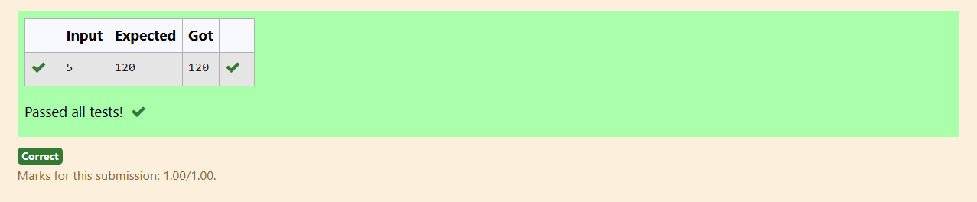

**AIM:**

Write a C program to find the sum first N natural numbers.

**PROGRAM:**

#include<stdio.h>

int main()

{

int n;

scanf("%d",&n);

int sum=0;

for(int i=1;i<=n;i++)

{

sum=sum+i;

}

printf("%d",sum);

}

**OUTPUT:**

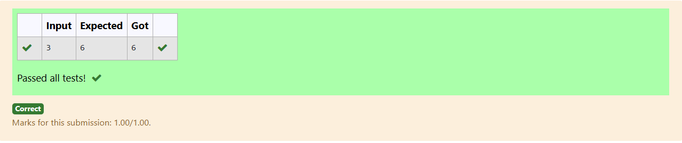

**AIM:**

Write a C program to find the Nth term in the fibonacci series.

**PROGRAM:**

#include<stdio.h>

int main()

{

int a=0,b=1,c;

int n;

scanf("%d",&n);

if(n==0)

printf("%d",a);

else if(n==1)

printf("%d",b);

else

{

a=0,b=1,c=0;

for(int i=0;i<(n-1);i++)

{

c=a+b;

a=b;

b=c;

}

printf("%d",c);

}

}

**OUTPUT:**

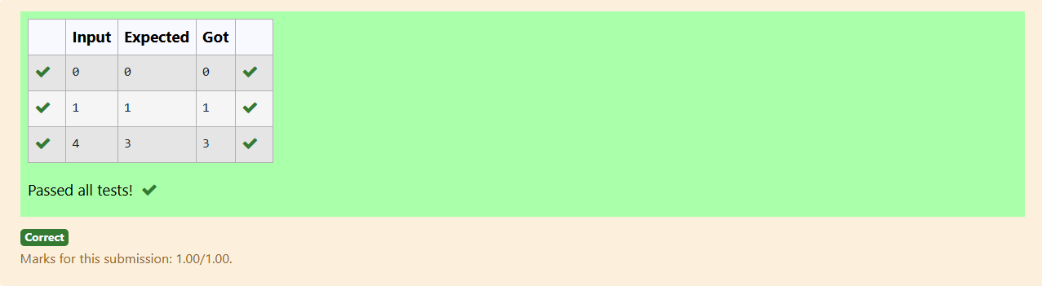

**AIM:**

Write a C program to find the power of integers.

**PROGRAM:**

#include<stdio.h>

int main()

{

int n,m;

scanf("%d %d",&n,&m);

int p=1;

for(int i=0;i<m;i++)

{

p=p*n;

}

printf("%d",p);

}

**OUTPUT:**

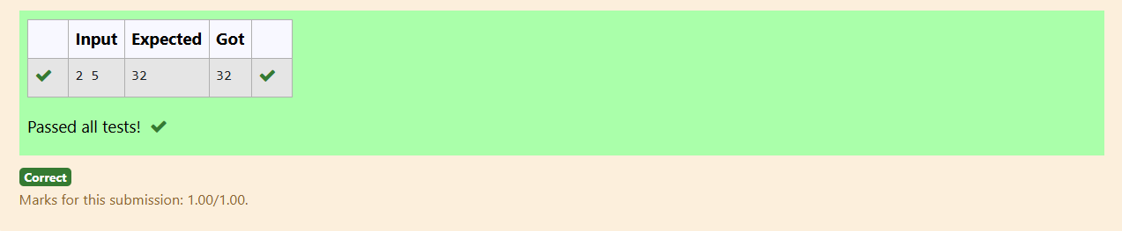

**AIM:**

Write a C program to find Whether the given integer is prime or not.

**PROGRAM:**

#include<stdio.h>

int main()

{

int n;

scanf("%d",&n);

int c=0;

for(int i=2;i<=n;i++)

{

if(n%i==0)

c=c+1;

}

if(c==1)

{

printf("Prime");

}

else

{

printf("No Prime");

}

}

**OUTPUT:**

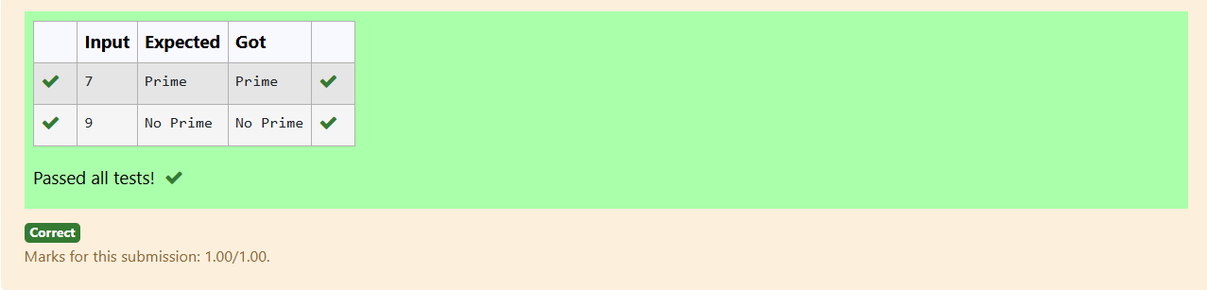

**AIM:**

Write a C program to find the reverse of the given integer?

**PROGRAM:**

#include<stdio.h>

int main()

{

int n;

scanf("%d",&n);

int rem,rev=0;

while(n>0)

{

rem=n%10;

rev=rev*10+rem;

n=n/10;

}

printf("%d",rev);

}

**OUTPUT:**

